A GLOBAL EXAMPLE: THE EVER-DECREASING POVERTY RATE IN BELGIUM

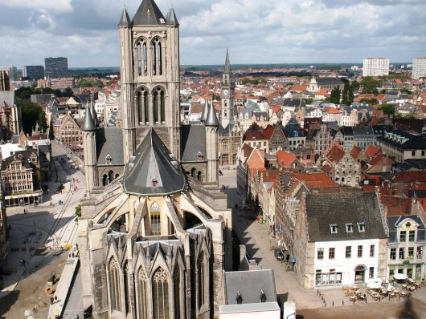[Belgium](https://borgenproject.org/top-10-facts-about-hunger-in-belgium/) is a country located in western Europe between [France](https://borgenproject.org/poverty-france-overlooked/) and the Netherlands. It became an independent nation from the Netherlands in 1830 and was then controlled by Germany during World War I and II. The foundation of the EU and NATO allowed the country’s capital, Brussels, to become the home for numerous international organizations. The influence of the organizations and membership in the EU and NATO has allowed the [poverty rate in Belgium](https://borgenproject.org/facts-about-poverty-in-belgium/) to remain low.

Currently, the poverty rate in[Belgium](https://borgenproject.org/top-10-facts-about-living-conditions-in-belgium/) rests at 15 percent. Like many other European nations, [Belgium](https://borgenproject.org/common-diseases-in-belgium/) has a high standard of living and per capita income. Belgium consistently ranks among the top nations in the Human Development Index (an index that measures the quality of life in countries). In 2007, Belgium ranked number seven, which was ahead of the country it once was a part of — the Netherlands.

When measured in 1992, 3.7 percent of the population was in the lowest 10 percent of the income bracket. About 9.5 percent were in the lowest 20 percent, 14.6 percent were in the second 20 percent, 18.4 percent were in the third 20 percent and 23 percent were in the fourth 20 percent of income.

The highest 20 percent made up 34.5 percent and the highest 10 percent made up 20.2 percent of income. These statistics indicate the low poverty rate in Belgium and the little income inequality.

Although there is little income inequality in Belgium, 16.7 percent of people under the age of 18 lived in families that fell below the poverty line. Since 2012, the risk of being under the poverty line for people under the age of 18 has decreased considerably. Thanks to numerous social welfare programs, the risk of a person under 18 being under the poverty line in Belgium has fallen from 27 to 15 percent.

The social welfare system is a primary reason for why the poverty rate in Belgium remains low. The country has programs for family allowance, retirement, medical benefits, unemployment insurance and even a program that provides a salary in the event of an illness.

Belgium is a country that has managed to tackle the issues of income inequality and poverty while remaining a small nation. The social welfare system in Belgium in conjunction with its cooperation with the EU and NATO are one of the primary reasons for the success of the country. Thus, countries interested in lowering their poverty rates should follow Belgium’s example.

– *Nicholas Beauchamp*

Referencing

a. (2020, July 2). A Global Example: The Ever-Decreasing Poverty Rate In Belgium. The Borgen Project. Retrieved January 15, 2022, from <https://borgenproject.org/poverty-rate-in-belgium/>

(2020)